Types of Illusions
- Shepard Tone Illusion
The Shepard Tone is a fascinating auditory illusion that creates the perception of a continuously ascending or descending pitch, even though the tone never actually gets higher or lower. This effect is achieved by overlapping notes that are one octave apart, with each note fading in and out in such a way that the beginning or end of any given scale is indistinguishable.
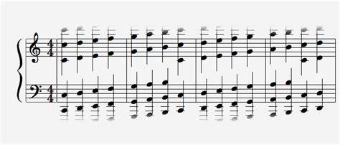
- Phantom Words Illusion
The Phantom Words Illusion is a captivating auditory phenomenon where listeners perceive words or phrases that aren’t actually present in the sound stimulus. This illusion was first demonstrated by Diana Deutsch.
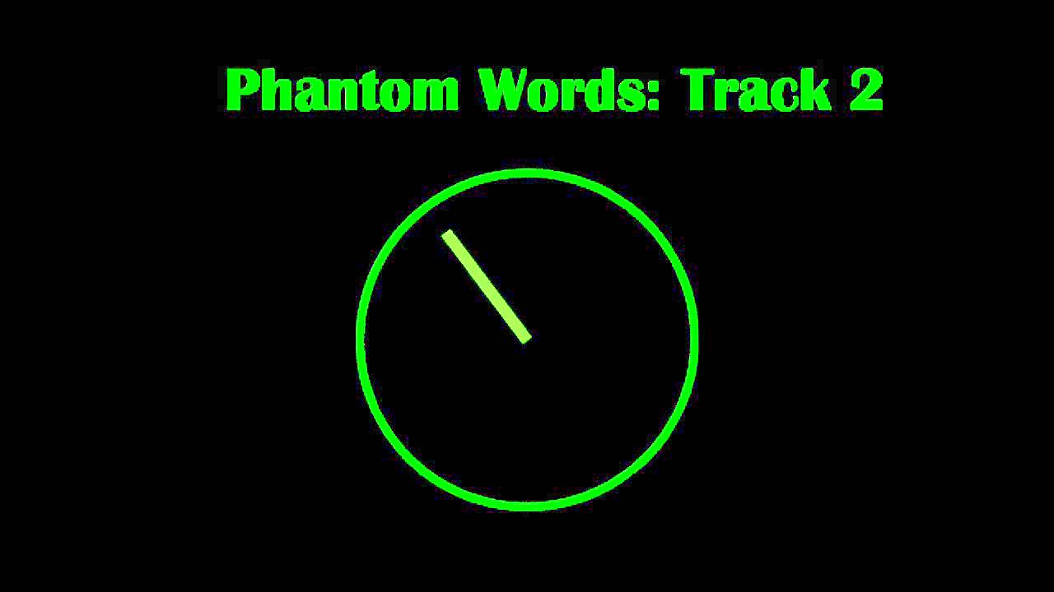

- Cutaneous Rabbit Illusion
Repeated rapid stimulation at the wrist, then near the elbow, can create the illusion of touch at intervening locations along the arm (as if a rabbit is hopping along the arm). This is known as the “cutaneous rabbit effect” (CRE).
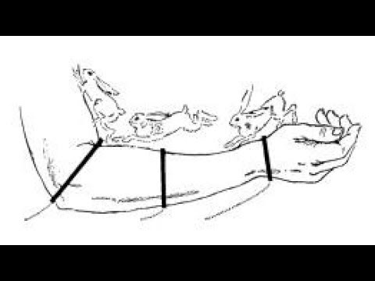
- False Memory Illusion
False memory illusion is a fascinating psychological phenomenon where a person recalls something that did not actually happen or recalls it differently from the way it actually happened. This can be influenced by various factors, such as suggestions from others, the passage of time, or even the brain’s own mechanisms for filling in gaps in memory.
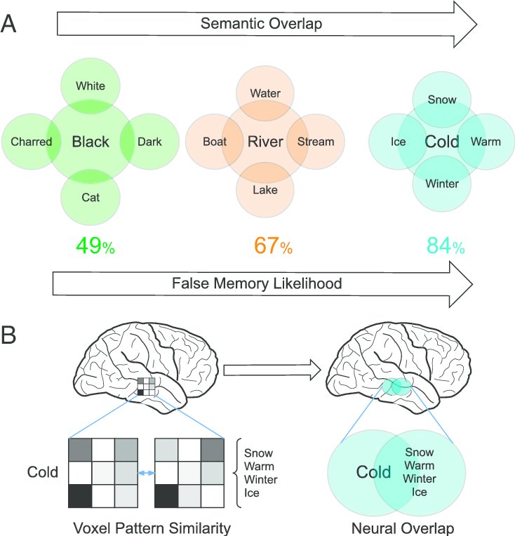

- Chronostasis
The stopped clock illusion is a common occurrence where the second hand of an analog clock appears to stay still for longer than normal when looking at it for the first time.
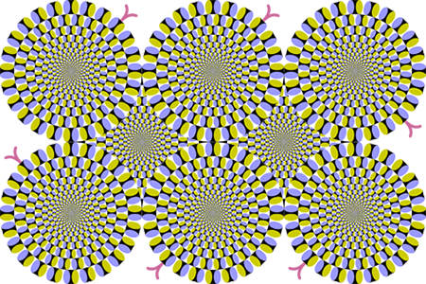
- Telescoping Effect
In cognitive psychology, the telescoping effect (or telescoping bias) refers to the temporal displacement of an event whereby people perceive recent events as being more remote than they are and distant events as being more recent than they are.
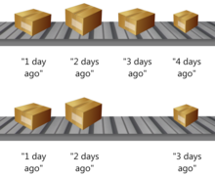
- The Spotlight Effect
The spotlight effect is a psychological phenomenon where people tend to overestimate how much others notice them. It leads individuals to believe that their mistakes or perceived flaws are more visible to others than they actually are.
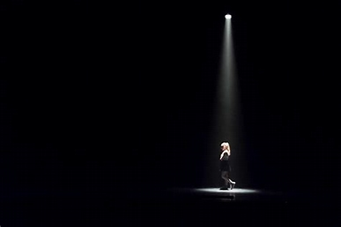
- Illusion of Transparency
The illusion of transparency is a tendency for people to overestimate the degree to which their personal mental state is known by others.
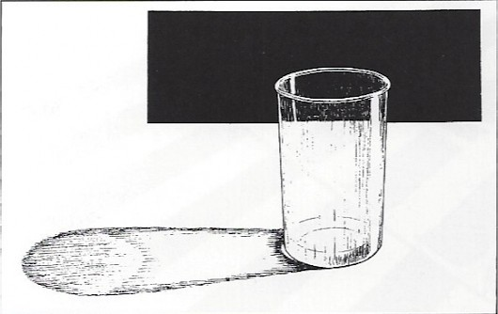
- Hollow-Face Illusion
The Hollow-Face illusion (also known as Hollow-Mask illusion) is an optical illusion in which the perception of a concave mask of a face appears as a normal convex face.
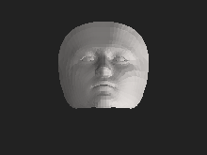
- Autokinetic Effect
The Autokinetic effect (also referred to as autokinesis and the autokinetic illusion) is a phenomenon of visual perception in which a stationary, small point of light in an otherwise dark or featureless environment appears to move.
